

**Date:** December 9, 2018

FINAL PROJECT REPORT

Class ID: 100337

Subject: Operating System

Group Members:

1. Muhammad Nauman (61673)
2. Wasiq Ahmed (61633)
3. Muhammad Sami (8008)
4. Sameer Rehman (61635)
5. Faizan Khan (61552)

Submitted To:

Sir Ayaz Khan

Table of Contents

**1.1 INTRODUCTION1**

**1.2 FINAL PROJECT FEATURES1**

**1.3 INTERIM PROJECT FEATURES1**

**1.4 PROJECT SCREEN SHOTS AND EXPLAINATION1**

**1.1 INTRODUCTION:**

Task Manage is an application built on C#. It will show all running process with details. It will also display the most commonly used performance measure of the processes.

**1.2 FINAL PROJECT FEATURES:**

* Display all currently running process including detail and Process ID.
* Kill any process.
* Display graph of memory usage and CPU usage based on overall performance of computer.
* Display memory usage, CPU usage, Status, start date, heap size and stack size etc. of each process.
* Display all information about Network/Ethernet.

**1.3 INTERIM PROJECT FEATURES:**

* Display all currently running process including Name, Status, Start TIme and Process ID.
* Kill any process.
* Display graph of memory usage and CPU usage based on over performance of computer and hardware information.

**1.4 PROJECT SCREEN SHOTS AND EXPLAINATION:**

1. Show all running process with details.

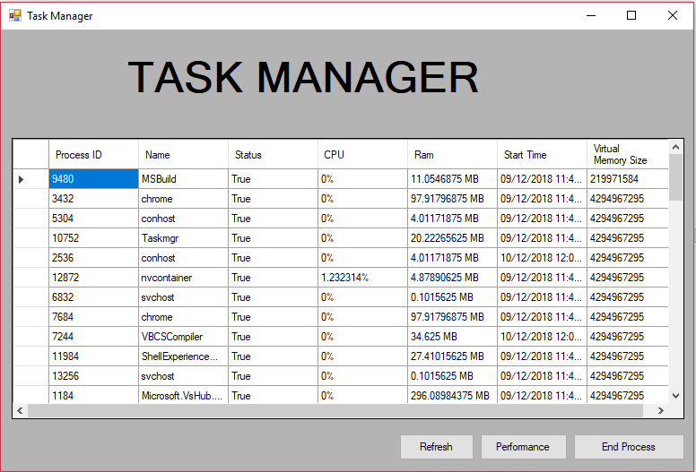

1. Killing “MS PAINT” process before and after.

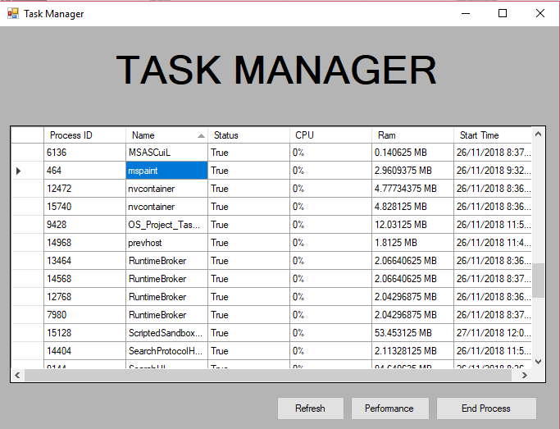

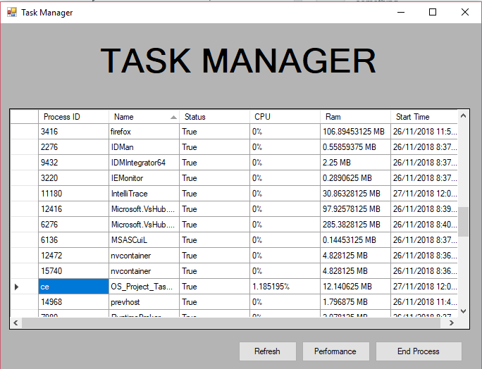

1. Monitoring CPU and Memory Usage in graph and also in percentage. Also Monitoring Hardware information in preformation tab.

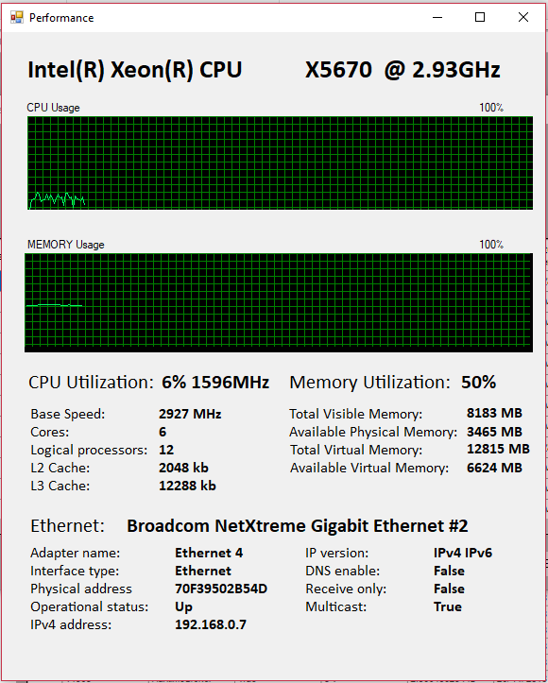

**NOTE:** code explanation is in file **“OS_Project_TaskManager”** in the form of comments. Please open this project on **Visual studio** and after running this program please wait for 10-15 seconds.